Student Name: Amal Ahmed Hakami

Student ID: 202000886

1) name your template title: comp333_fle_xxxxxxxxxx., where xxxxxxxxx is your university id number.

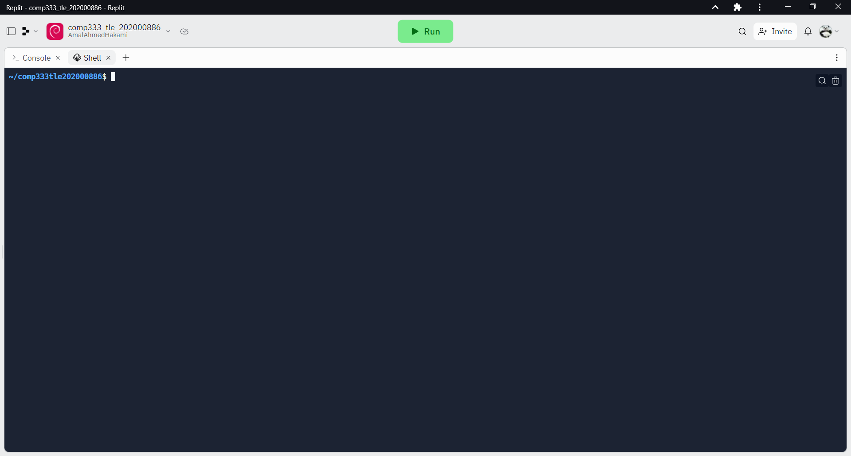

2) Display the full path name of the current location.

Pwd

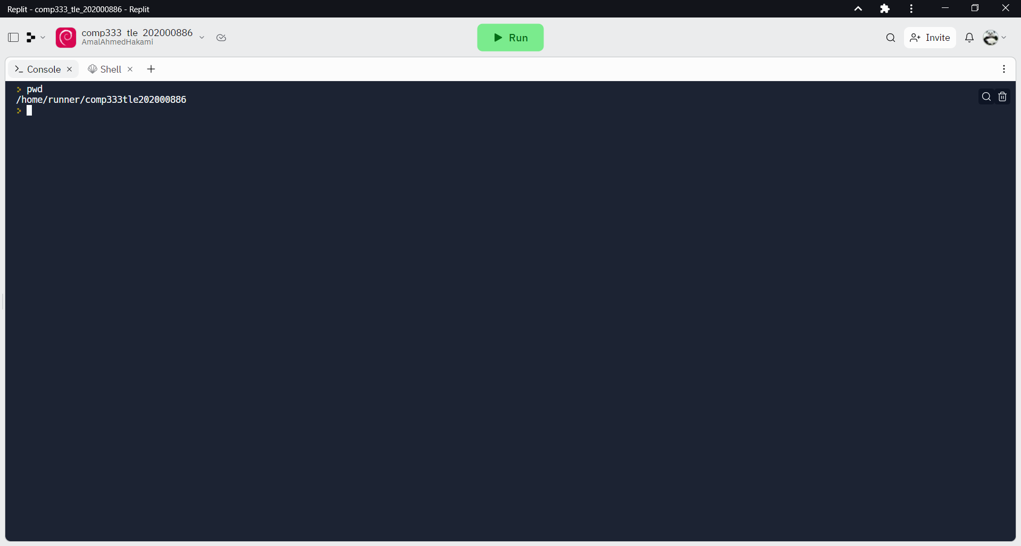

3) Install the file package.

sudo apt-get install file

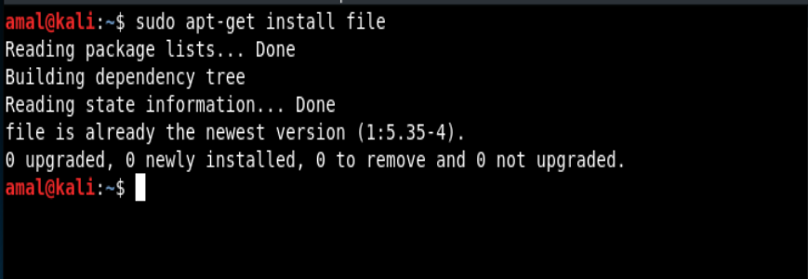

4) Create two directories: regions, and cities.

mkdir regions cities

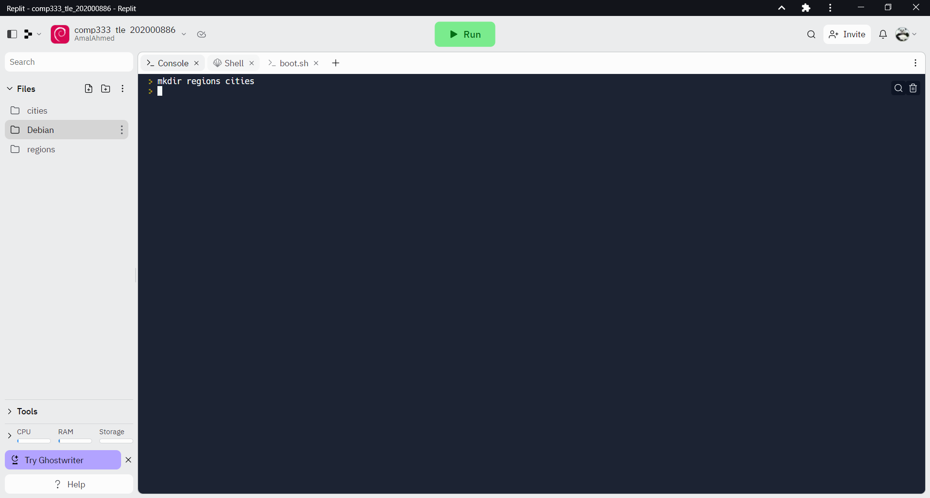

5) Create 5 files in the regions directory: tabuk.txt, Makkah.com, eastern.pdf,Jazan.mp4, and Najran.gif.

touch regions/tabuk.txt regions/Makkah.com regions/eastem.pdf regions/Jazan.mp4 regions/Najran.gif

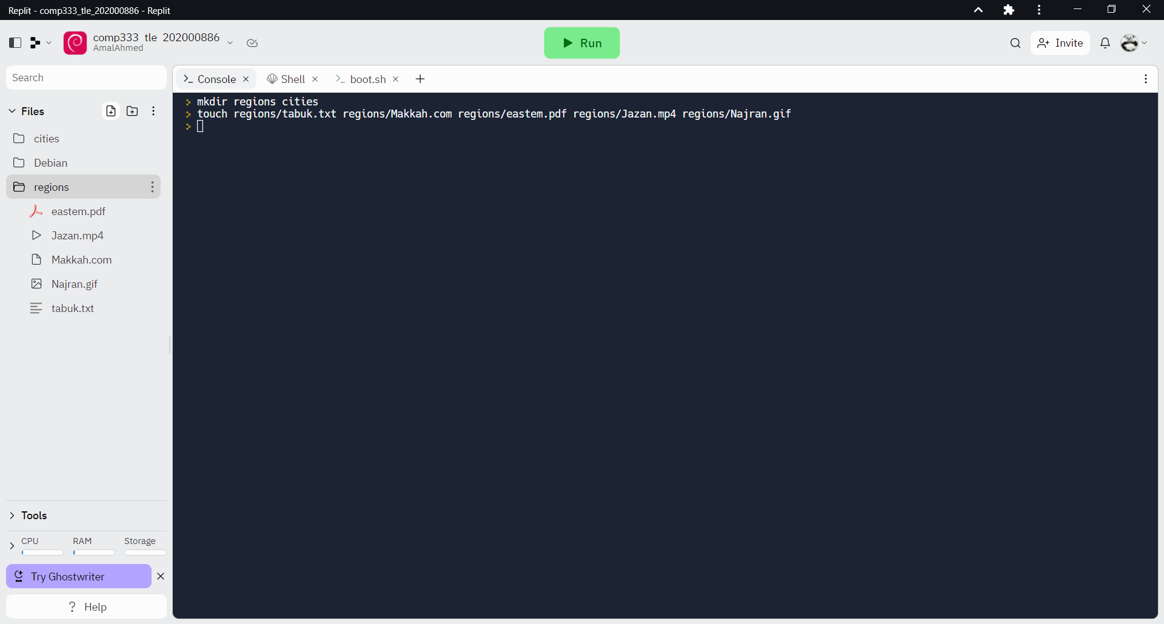

6) Create 5 files in the cities directory: sabia.txt, Jeddah.bmp, Riyadh.net,

Khobar.docx, and abha.txt

touch cities/sabia.txt cities/Jeddah.bmp cities/Riyadh.net cities/Khobar.docx cities/abha.txt

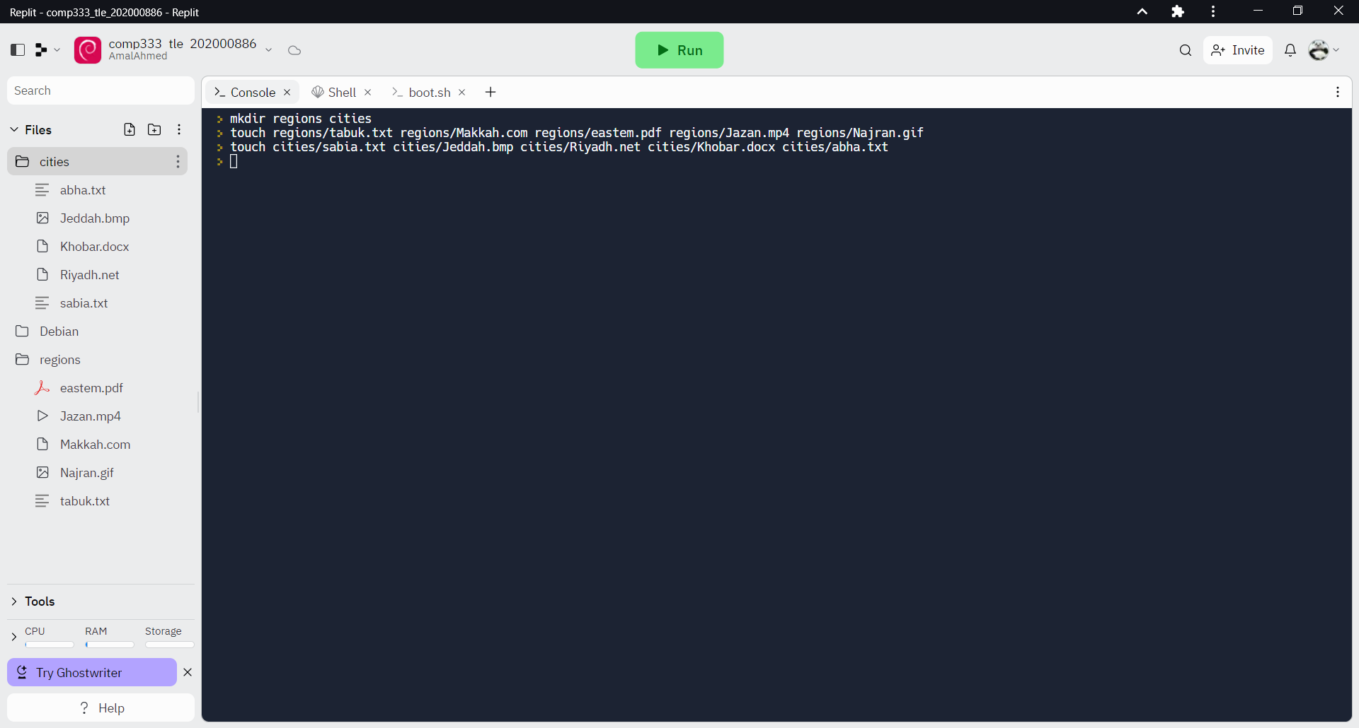

7) Display the content of the regions directory.

ls regions/

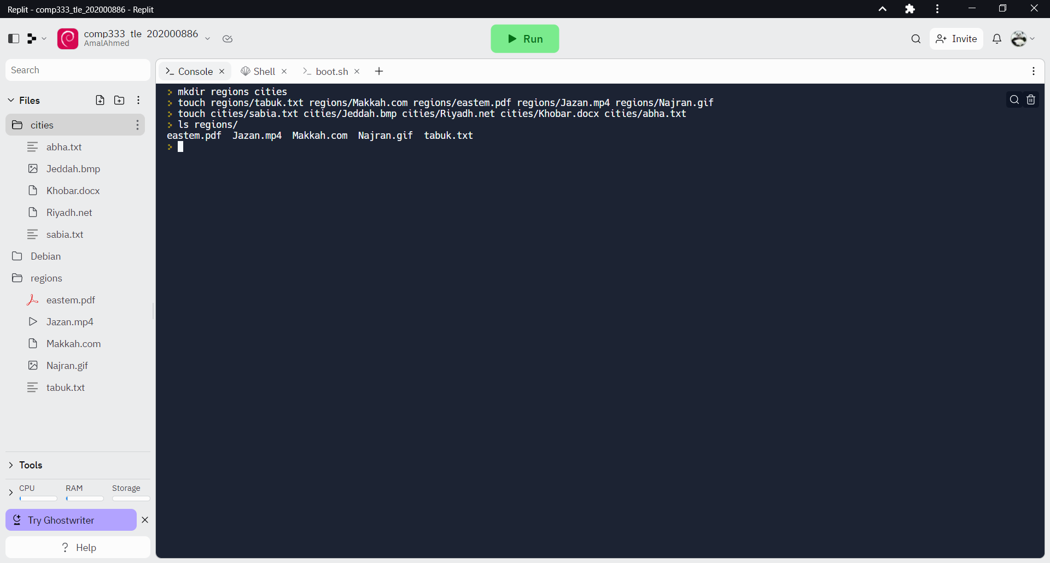

8) Display the content of the cities directory

ls cities/

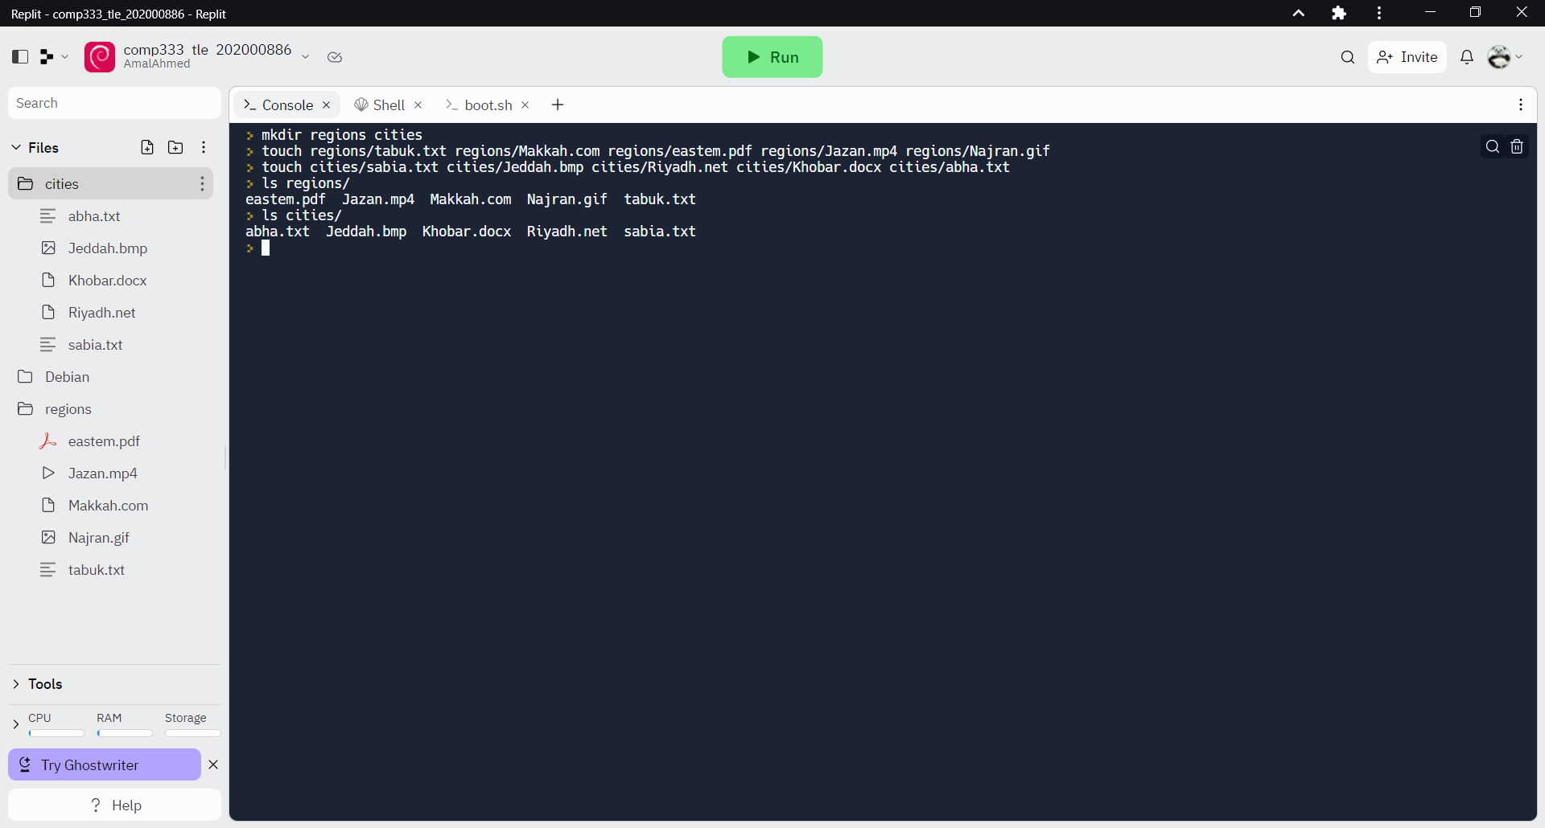

9) Display the beginning of the file: extended_states located in var/lib/apt

head /var/lib/apt/extended_states

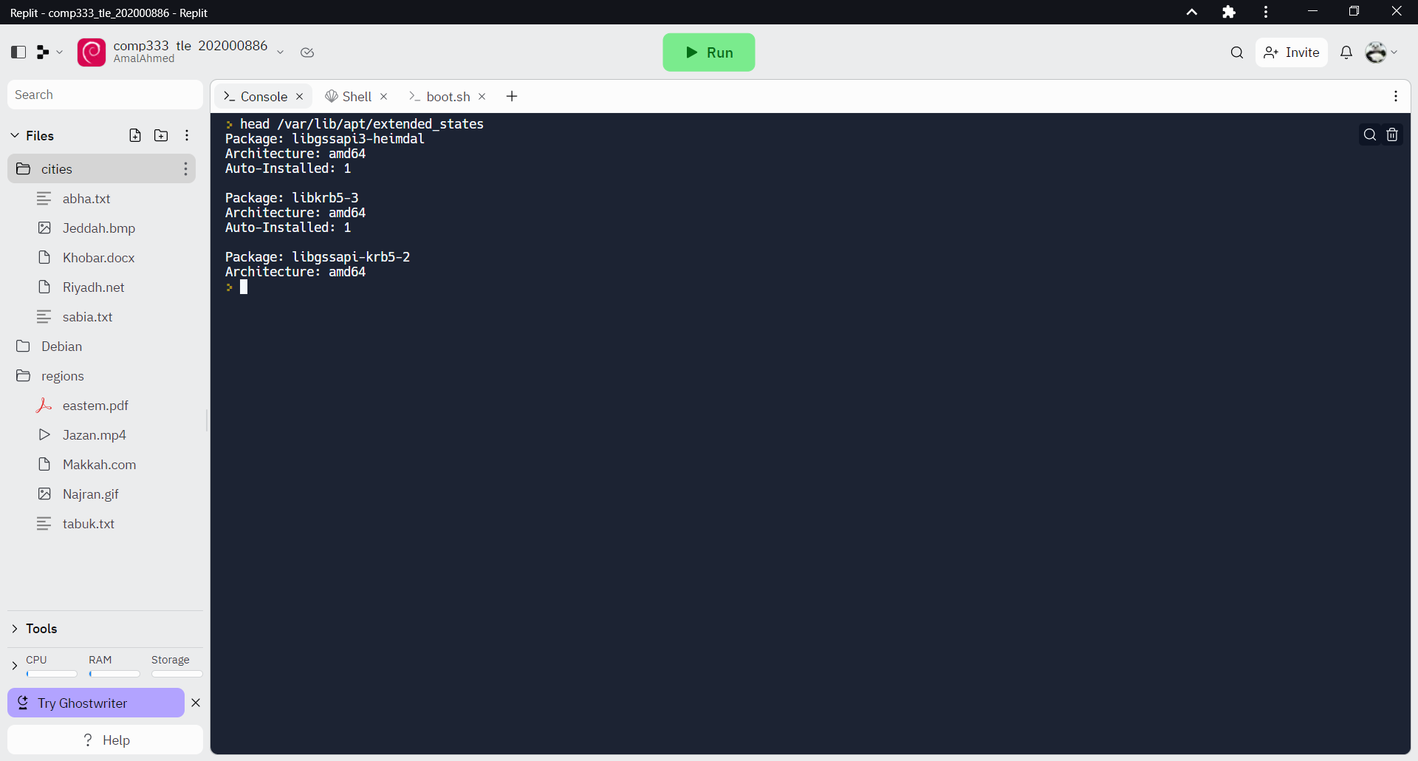

10) Display all processes.

ps –A

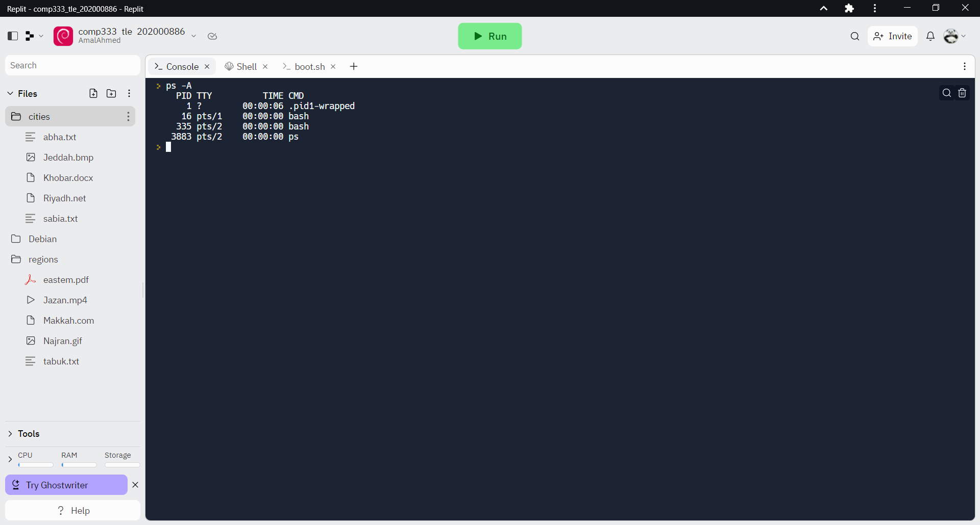

11) Add/create three users: guest1, guest2 and guest3

sudo useradd guest1

sudo useradd guest2

sudo useradd guest3



12) Display the passwords of the guest1, guest2 and guest3.

sudo grep '^guest[1-3]:' /etc/shadow

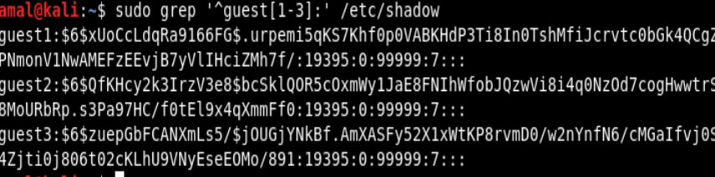

13) Add/create a group named: HelloGuests.

Sudo groupadd HelloGuests

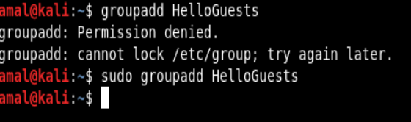

14) Add guest1, guest2, and guest3 to HelloGuests group.

Sudo usermod -aG HelloGuests guestl

Sudo usermod -aG HelloGuests guest2

Sudo usermod -aG HelloGuests guest3

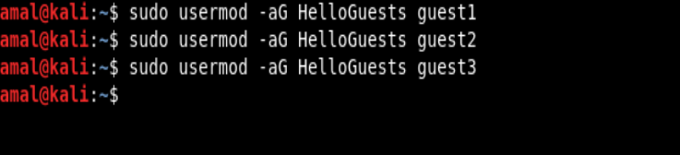

15) Display/show that guest1, guest2, and guest3 have been added to group:

HelloGuests.

Sudo cat /etc/group | grep HelloGuests

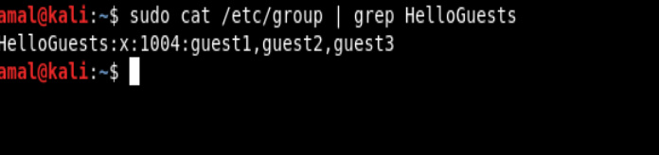

16) Print/echo ‘kingdom of Saudi Arabia” to a file: /usr/doitlist.doc

echo "kingdom of Saudi Arabia" > /usr/doitlist.doc

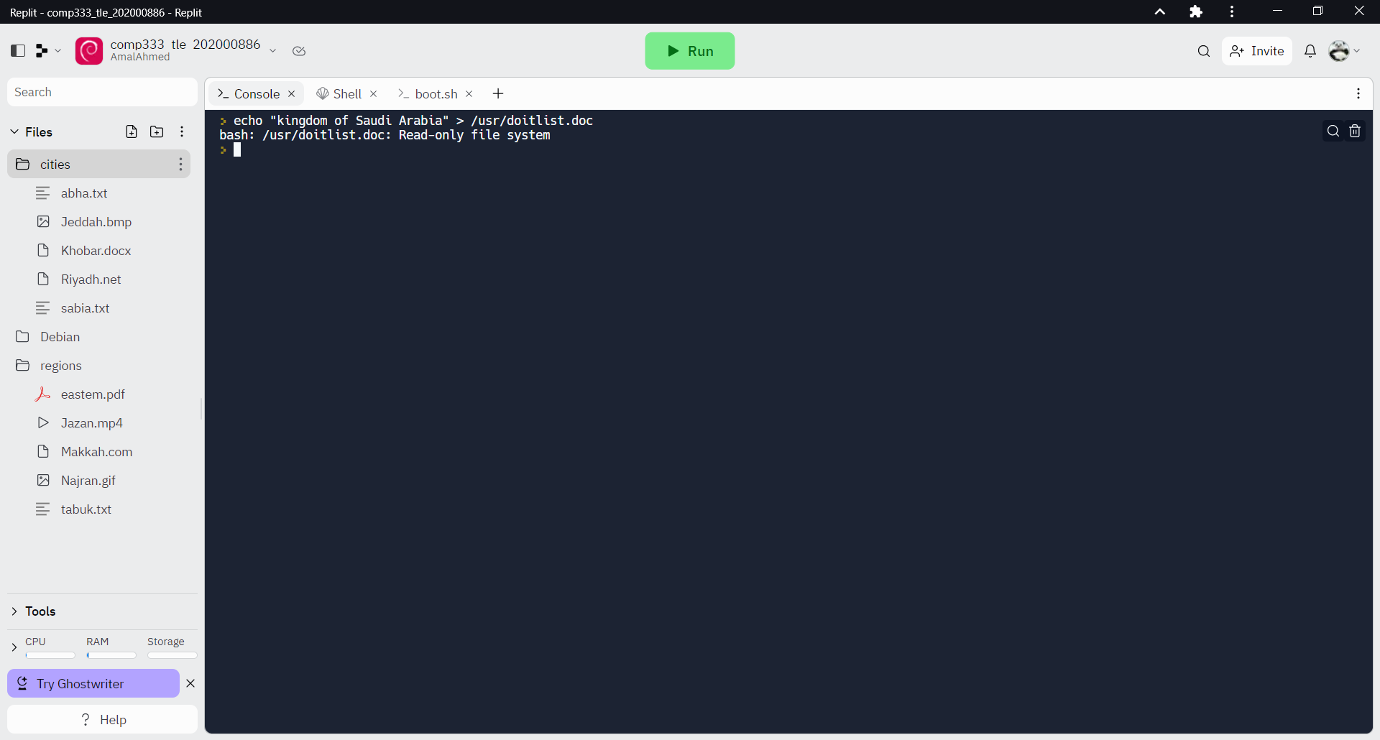

17) Open the file doitlist.doc, and show what is inside it.

cat /usr/doitlist.doc

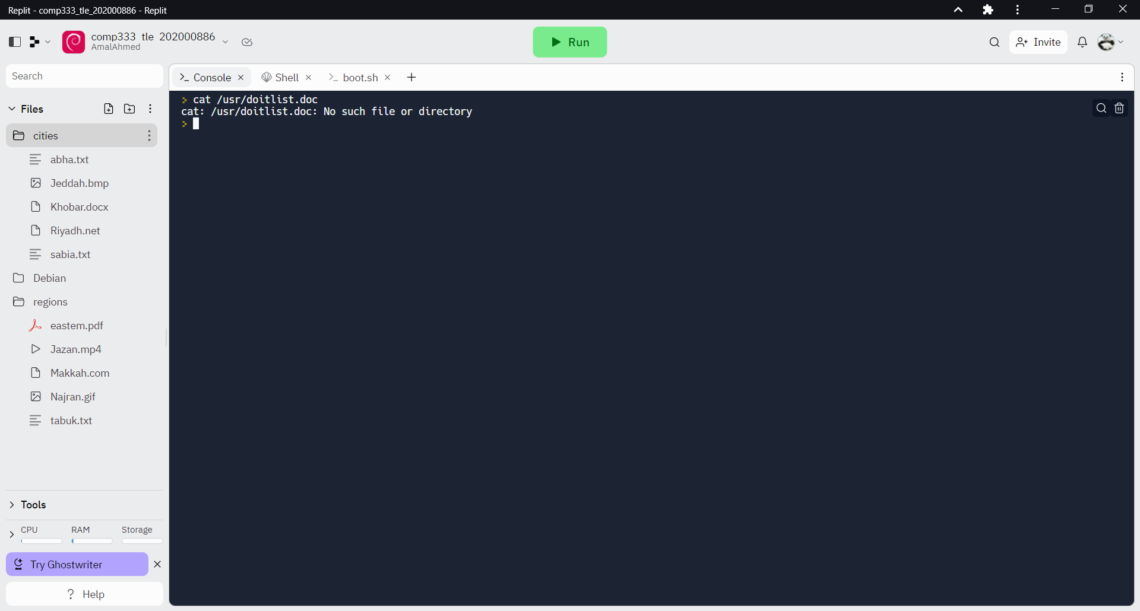

18) Write an executable file name: helloworld.exe, where it defines two variables:

a=15, b=30, and c=a+b, then echo/print the value of c.

touch helloworld.exe

#!/bin/bash

a=15

b=30

c=$((a + b))

echo $c

